Manual Building Workshop

**A hands-on workshop to utilize Microsoft Word® to create a manual.**

**May 6, 12 – 1 p.m., School of Nursing Computer Lab (HK4007)**

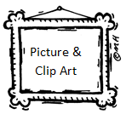

**Automatic** Table of Contents  
Linking documents

# Style Sets (Headings)

Custom Dictionaries

Shortcuts and what all those buttons are at the top of the screen

Highlighting, Shading, and other use of color

Using margins and spacing

Text boxes and **word art**

Headers & Footers

|  |  |
| --- | --- |
| Tables |  |
| Auto design |  |
| Developer | Active Buttons |
|  |  |

**Space is limited to 20 individuals.**

RSVP to Laura Frost via email at [laura.frost@louisville.edu](mailto:laura.frost@louisville.edu), sending an example of a manual you are working on, question(s) you have, and a tip to share.